Dear WMRF,
Firstly thank you for your support, it has been greatly appreciated in making this service a reality.
I received some very positive feedback from the audience at the last WMRF research meeting.
Some of the feedback was really positive and somewhat common sense i.e. that this programme should be available everywhere and also point of care technology should be in all emergency departments.
The pathway was presented at the Cardiac Society of New Zealand, 2018 annual conference where the programme picked up an affiliates award for 2018. The WMRF was acknowledged and thanked for its support.
The rural accelerated chest pain pathway (and now referred to the accelerated chest pain pathway) proof of concept was completed June 2018.
The pathway has been shown to be safe so far and the team has seek support from the National Cardiac network to move forward towards validation of the tool. The cardiac network have requested a larger cohort n= 1000 patient with a 995 confidence interval and they will seriously consider. The pathway has now been extended into rural hospitals with adaption to complete the care of the patient via Dr Rory Miller whom commence rollout late 2018
The pathway continues in the Waikato region by the original 10-12 general practices. We have had some practice withdraw due to low recruitment and therefore we have implemented into urgent care facilities, (Victoria Clinic ) and shortly Anglesea Clinic that has added additional supplementary data.
The programme went live in Tairawhiti last October 2018. We are starting to see patient flow as clinician confidence grows. The appointment of Dr Gerry Devlin, Cardiologist to Gisborne hospital will further strengthen the future use of the pathway .
The programme will go live in Taranaki in the 1st half of the 2019 with and information, sign up evening on the 28th Fe 2019.
Results to date (Please note for the purpose of pending publication the total cohort was n=199)
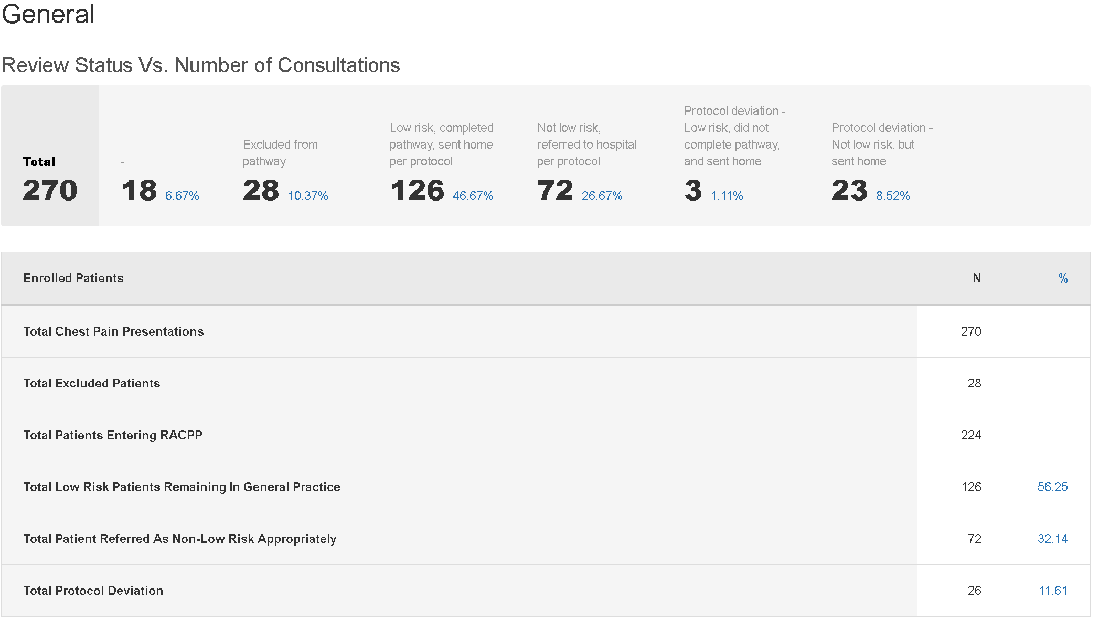
Total chest pain presentations to primary care n=270 in which 28 we excluded as not suitable, therefore 224 continue on to be risk stratified.
72 patient were considered of not low risk and were discuss or referred on to be reviewed by General Medicine or Cardiology. Not low risk patient are deemed not suitable for primary care management.
Over 56% ( n= 126) of the cohort were deemed of lower risk to manage in primary care and historically all these patients would have resulted in an emergency department presentation.
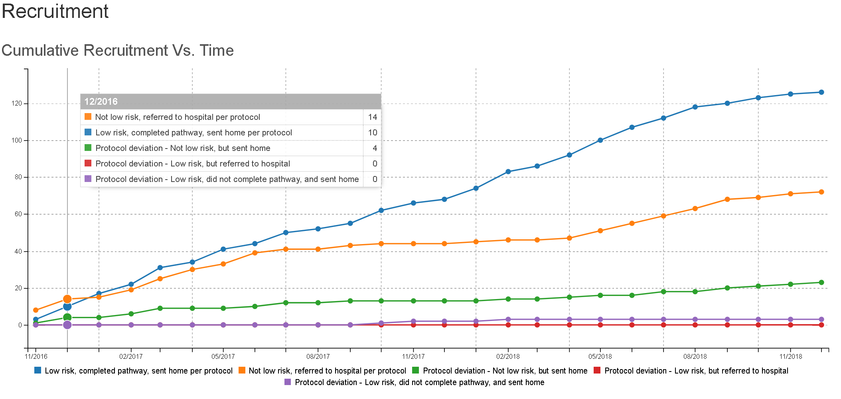
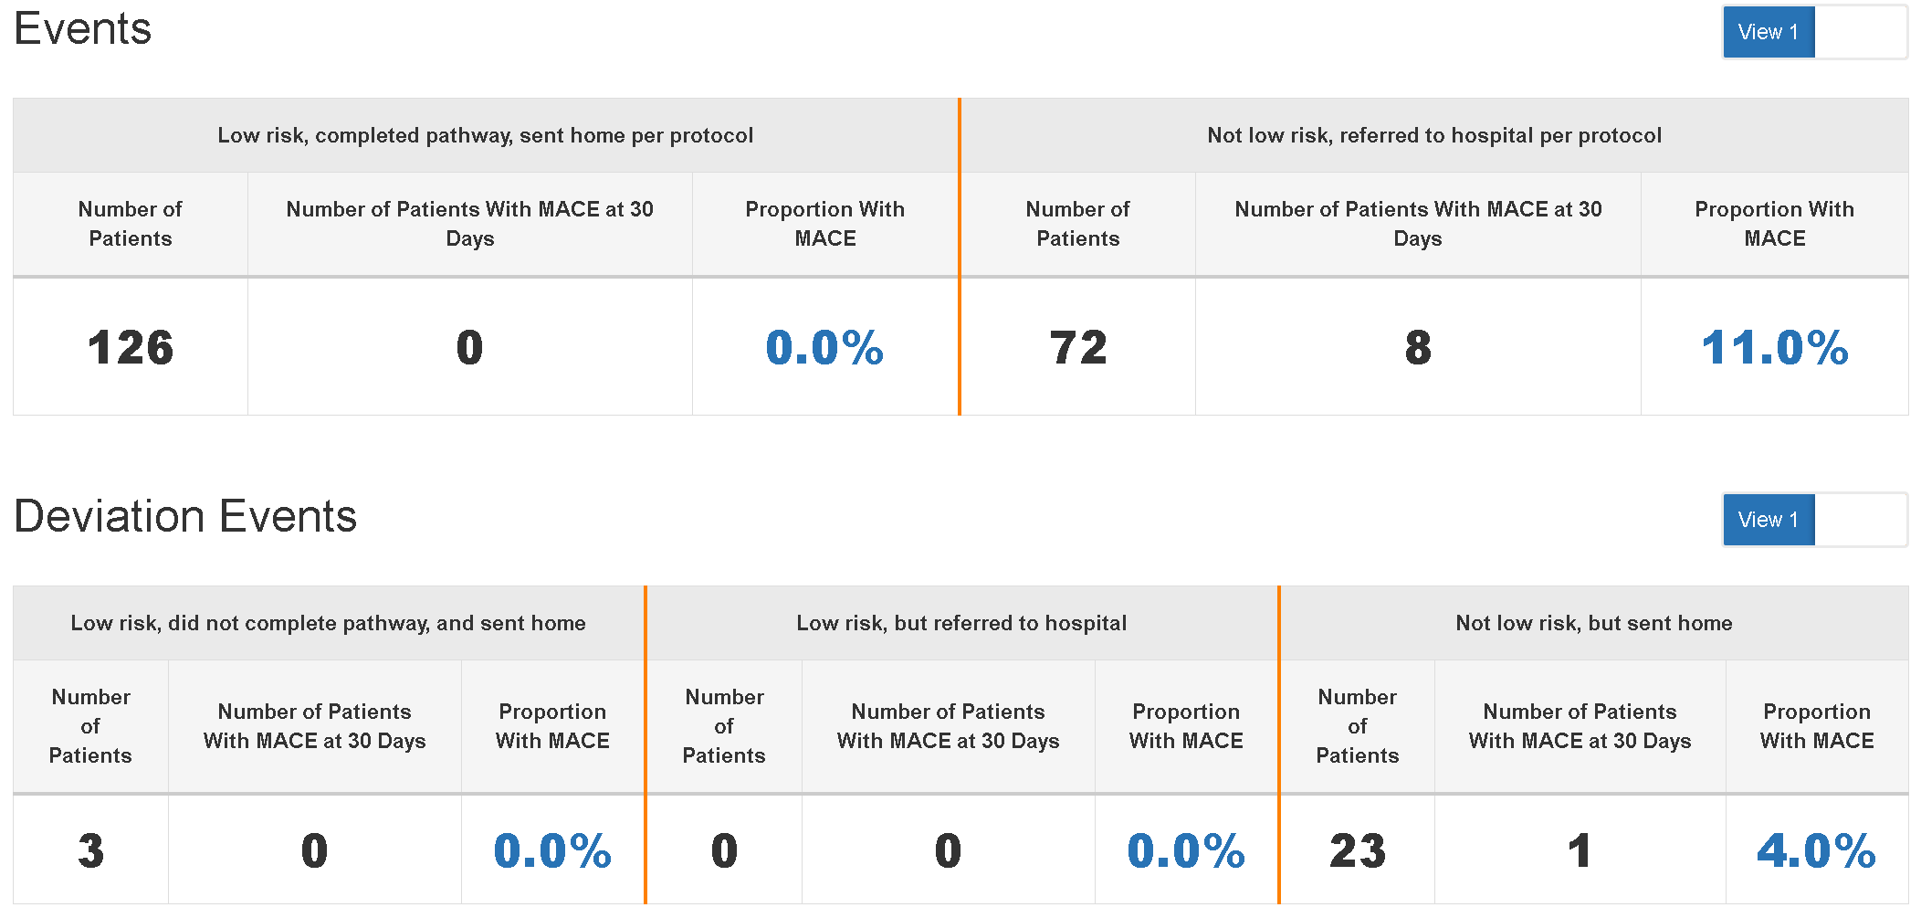
Of the 126 patients treated in primary care, no patients went on to a have a Major Acute Coronary Event (MACE).
Of the not low risk group (n=72) whom were reviewed by Cardiology department 8 patients have proceed on to a MACEW event with in 30 days.
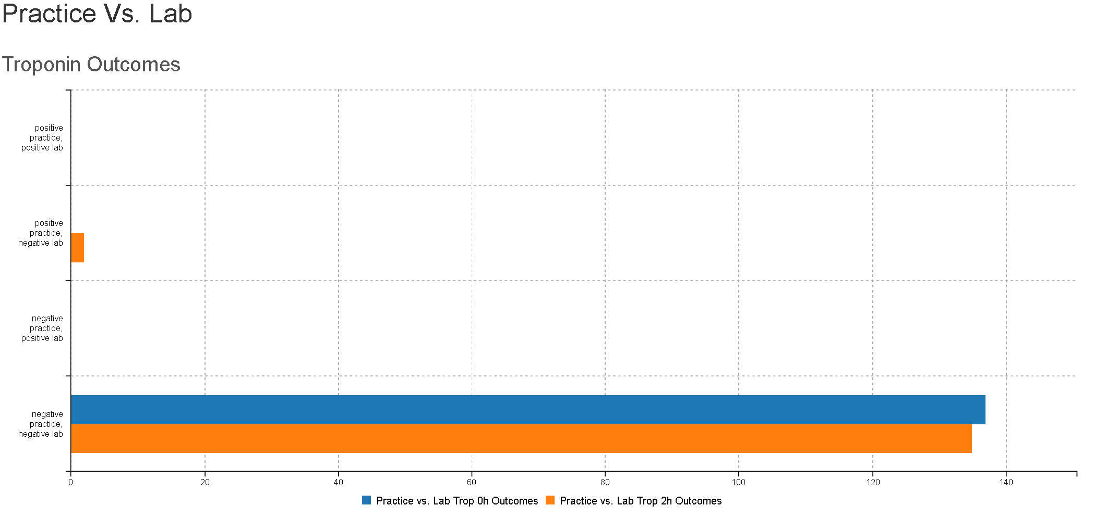
The proof of concept when originally conceived the incorporation of point of care testing had a perception that POC was not accurate.

Data was collected that demonstrated no false negatives in practice. One false positive in practice occurred but is explained that as a safety measure of the programme the research team lowered the positive threshold to 0.04ng as a safety measure versus the normal setting of 0.08ng.

Conclusions and recommendations
- The combination of EDACS and POCT testing currently shows that patients are safely managed in the community.
- ED presentations show there has been no re-presentation of a low risk patient managed in primary care.
- There have been no MACE events for the low risk cohort to date.
- 8 (11%) MACE event has occurred with the not low risk cohort referred to hospital to date.
- The coinciding blood sample tested at the lab showed only 1 result as positive in practice/negative in lab (due to safety range being applied in practice
Subjective themes
- General practice is now speaking the same clinical language as our secondary partners, therefore easier referral process.
- A standardised approach to the assessment of chest pain appears to be effective, however deviation from protocol remains challenging.
Whats Next
- The proof of concept has been a achieved and formally ended 30 April 2018.
- Worked towards national endorsement, national policy and national registry.
- Expand primary care programme in the Midland region, including rural and urban practices.
- Expand programme into all rural hospital settings and establish point of care troponin.
- The program to support an afterhours solution.
- Consider nurse driven models and St John applications.
Financials
Please find attached a financial breakdown. The funding that has been unspent comes from the DHB to support the ongoing patient episodes in the Waikato region until a decision to continue support and wider roll out of the programme.

Please don’t hesitate to contact should the information provided not be indepth enough. I am more than happy to present to the WMRF again. I will forward on the publication should we be lucky enough to be accepted

Kind Regards
Tim Norman

